***Class D Voltage-source Half-bridge Inverter***

Created By:

Yaoyu Li

**1.Introduction**

In this project report, I choose the Class D voltage-source half-bridge inverter as the time-domain simulation model. I use the Matlab/Simulink software to show current and voltage waveforms in its series-resonant components at different values of the loaded quality factor QL and to illustrate how the voltage transfer function changed with the switching frequency and QL.

**2.Theory**

**Figure 1. Circuit Diagram**

In the Class D voltage-source half-bridge inverter as shown in the Figure 1, a capacitor and an inductor are connected in series to a resistance. It is a DC-AC converter in half-bridge configuration, as shown in the Figure 1, *Q1* and *Q2* are switched alternately ,then a square wave is produced at the midpoint of them. A capacitor *C* and an inductance *L* are calculated so that the switching frequency equals the resonance frequency.

**3.** **Simulation**

**3.1 Simulation model**

**3.2 Blocks Used**

|  |  |  |  |
| --- | --- | --- | --- |
|  | Block Name | Function | Rating |
| 1. | Powergui | Environment block for simscape power systems specialized technology models | Simulation Type : Continuous |
| 2. | DC Voltage Source | Implement DC voltage source | Amplitude(V) :100 |
| 3. | IGBT/Diode | As a Controlled Switch |  |
| 4. | RLC Branch | Implements a linear branch as a series combination of R L C elements | According to different values of QL to obtain 3 sets of RLC values |
| 5. | Current Measurement | Measure the instantaneous current flowing in the connection line |  |
| 6. | Voltage Measurement | Measures the instantaneous voltage of the load |  |
| 7. | Signal Generator | Produce signal waveforms | Sine wave |
| 8. | Logical Operator | Performs the specified logical operation | NOT and AND |
| 9. | Repeating Sequence | Outputs a periodic scalar signal having a waveform that has been specified | Time values:  [0 0.005/15 .01/15 .015/15 .02/15] |
| 10. | Step | Provides a step between two definable levels at a specified time | Step time: 0.04 |
| 11. | Relational Operator | Perform the specified relational operation on the input | Relation Operator: >= |
| 12 | From and Goto | The Goto block passes its input to its corresponding From blocks |  |
| 13. | Scope | Display signals generated during simulation |  |

**3.3 Current and Voltage Waveforms with Different QL Values**

**3.3.1 Simulation with QL= 5.5**

In the first simulation case, I adopt all the data from the example 6.2 of the Chapter 6 in our text book, which has the frequency of 110kHz and the phase of 30。as shown in the following Figure. For these frequency and phase values , the 100 V input DC voltage source, the 90% inverter efficiency, and the IRF621 MOS- FETs (International Rectifier) with *rDS* =0.5 Ω, I will also apply to the loaded quality factor QL=2.5 and QL=10.5 simulations.

**Figure 2. The Value of the DC Voltage Source**

**Figure 3. The Value of the Frequency and the Phase**

Note: 110kHz= 691150.383 rad/sec and 30。= 0.523599 rad

For the simulation with QL= 5.5, the ratio f/f0 at full load is 1.054 calculated by the equation of (6.26). And using formula (6.41) and (6.10), the values of the resistance, the inductor and the capacitor in the resonant circuit corresponding to QL=5.5 can be obtained, as shown below:

**Figure 4. The Value of the Resonant Components (QL=5.5)**

After the simulation, the waveforms are given:

**Figure 5. The Inverter Waveforms with QL=5.5**

As can be seen, the first two waveforms describe the rectangular pulse samplings for the Switch 1 and 2. When the Switch 1 is on, the Switch 2 is off and vice versa. The current of resonant components is a sine waveform shown in the above third picture. For the voltage of the RLC series circuit, the waveform shaped like periodic trapezoids appeared in the last picture of Figure 5 and only have values when Switch 1 is on.

**3.3.2 Simulation with QL= 2.5**

In this section, the loaded quality factor QL value equals to 2.5, assuming the load resistance power PRi is 25W, and just like the example 6.2，the efficiency of the inverter is still 90%, the frequency is 110kHz, the phase value is 0.536 rad, the 100 V input voltage source is given and the IRF621 MOSFETs (International Rectifier) with rDS =0.5 ohm. Then the overall resistance value and the load resistance value can be calculated to be 54.713 ohm and 49.242 ohm respectively. Moreover, the equation (6.10) gives the inductor value is 220.07 uH and the capacitor value 11.87nF. For this part the ratio of f/f0 equals to 1.1221.

**Figure 6. The Value of the Resonant Components (QL=2.5)**

**Figure 7. The Inverter Waveforms with QL=2.5**

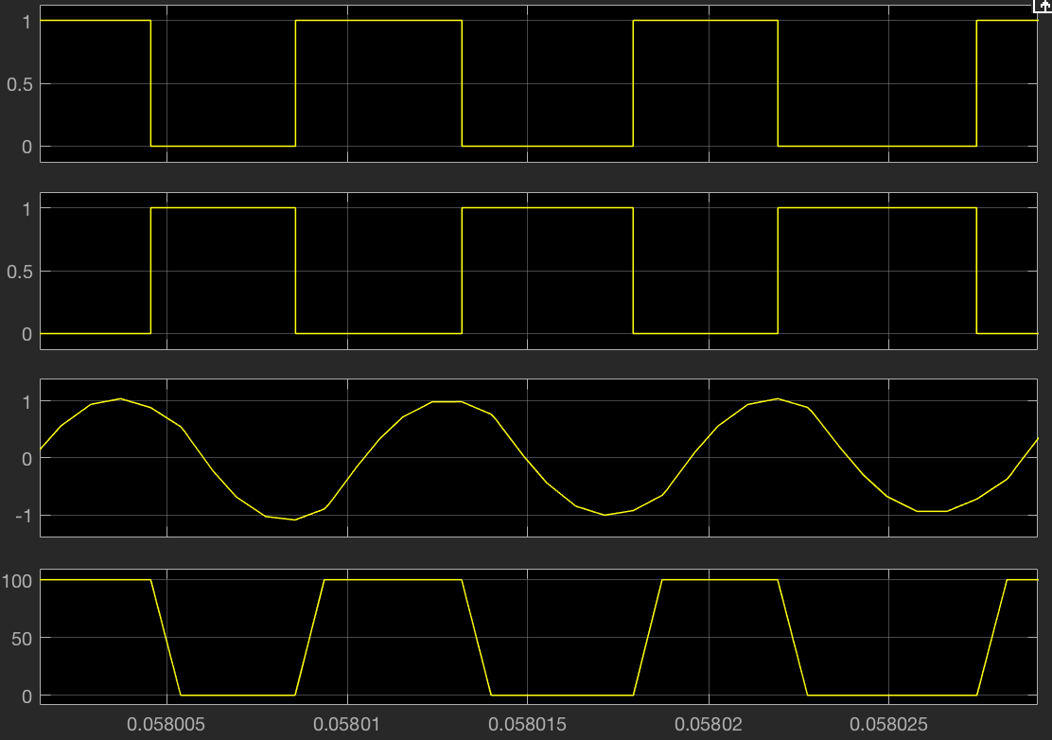

Take a careful look at the inverter simulation waveforms with QL=2.5, I find that, by using the same pulse generator and the identical DC voltage source (100V), the amplitude of the resonant components current has been reduced from 2A to 1A compared to the Class D voltage-source half-bridge inverter with QL=5.5 in the first simulation case of this report. Although the magnitude of the resonant components voltage dose not change which is still 100 V, its repeating period time is 4*10^-6 sec.

**3.3.3 Simulation with QL= 10.5**

In the third case, except VI=100V, f=110kHz, the inverter efficiency=90%, the phase=30 degrees keeping the same as the other two cases, set the power of the load resistor PRi=100W. The overall resistance value and the load resistance value are 13.67 ohm and 12.31 ohm respectively. Moreover, the equation (6.10) gives the inductor value is 213.49 uH and the capacitor value 10.36 nF. For this part the ratio of f/f0 equals to 1.028.

**Figure 8. The Value of the Resonant Components (QL=10.5)**

**Figure 9. The Inverter Waveforms with QL=10.5**

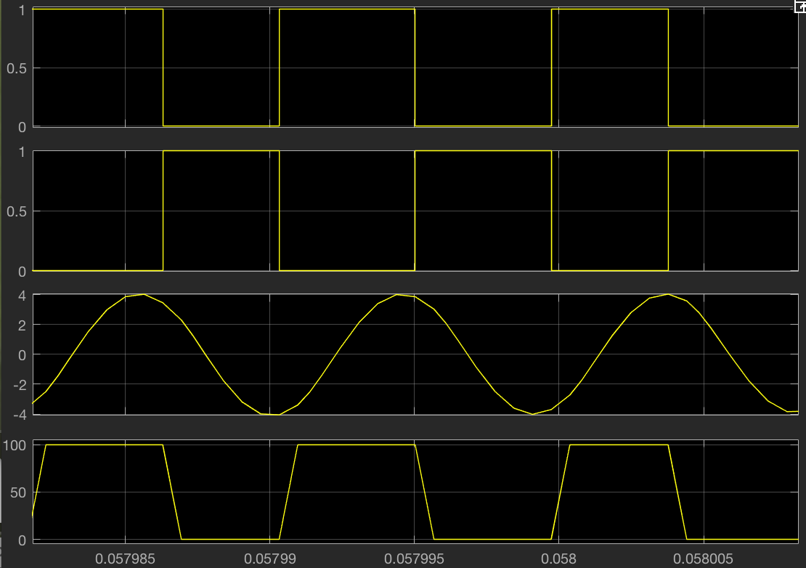

The inverter simulation waveforms with QL=10.5 shows that the amplitude of the resonant components current has been increased from 2A to 4A compared to the Class D voltage-source half-bridge inverter with QL=5.5 in the first simulation case of this report and it is even the 4 times of that of the inverter with QL=2.5. The magnitude of the resonant components voltage is still 100V when the Switch 1 is on and repeating period time is also 4*10^-6, the same as the other two simulation cases.

**3.4 The Voltage Transfer Function versus the Switching Frequency and QL**

**3.4.1 The Voltage Transfer Function versus the Switching Frequency**

For the series RLC resonant circuit, the magnitude of its voltage transfer function can be written like this:

The above equation shows clearly the relationship between the magnitude values of the voltage transfer function, the values of its resonant components, and the inverter frequency, based on this formula I created a Matlab program to plot their relationship by the Matlab transfer function and bodeplot commands:

After running this simulation program, I obtain the following result:

**Figure 10. The Voltage Transfer Function versus the Switching Frequency**

As can be seen, the magnitude of the voltage transfer function with the loaded quality factor QL=2.5 have the highest value, the second one is the curve with the QL=5.5 and the last one is the QL=10.5 curve. This phenomenon can be explained by the equation (6.59) in the Chapter 6:

The magnitude of the voltage transfer function |MVr| is in an inverse ratio to the square value of QL, that means the greater of QL value would cause the lower |MVr| value. This is the main reason for the curve of the QL=2.5 is higher than the other two.

**3.4.2 The Voltage Transfer Function versus QL**

For analyzing the relationship between the voltage transfer function and the loaded quality factor QL, I also reference the equation (6.59) and the simulation program is:

As mentioned before, the magnitude of the voltage transfer function |MVr| is in an inverse ratio to the square value of QL. Therefore, in the condition of same frequency ratios, the greater value of QL could make the magnitude of its voltage transfer function be less, as shown:

**Figure 11. The Voltage Transfer Function versus QL**

In this case, the inverter efficiency is 90%. Figure 11 verified that the |MVr| value increases with f0 > f, it decreases with f0 < f, and the maximum value of |MVr| occurred at f/f0=1.